# CS 340 README Template

*Use this template to complete your README file. When completing the template, keep the headings as they are so that your document has a clear organization. Remove the italicized prompt text after you have completed each section for a polished final document.*

## About the Project/Project Title

Project two dashboard was created to allow a user to search for and identify pets that can be adopted in the Austin, TX area.

## Motivation

The ability to ease querying steps and display information to the user is the motivation

## Getting Started

* Setting up mongod session
* Installing required files
* Running dashboard

## Installation

To first setup a mongoDB session:

1. Open a terminal window
2. #start mongo with authentication

/usr/local/bin/mongod_ctl start

1. #To load the data sets into this new MongoDB server environment, execute the following commands:

cd /usr/local/datasets

/usr/local/bin/mongod_ctl start-noauth

#**** copy the port number given in the output, example *****

#**** be sure to replace the ##### with the port number you were given

mongoimport --port ##### --db city --collection inspections ./city_inspections.json

1. mongoimport --port ##### --db AAC --collection animals --type=csv --headerline ./aac_shelter_outcomes.csv
2. Enable authentication
3. # now stop mongo

/usr/local/bin/mongod_ctl stop

# and start mongo with authentication, again make note of the

/usr/local/bin/mongod_ctl start

Create user profile:

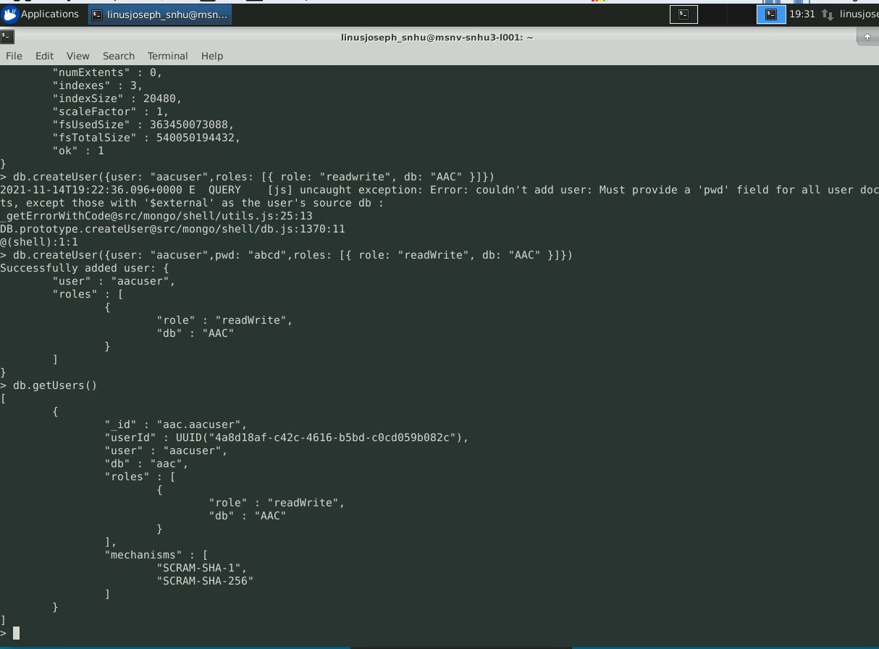

Then start a local copy and run the following:

* Download and place the file linusCRUD.py in home directory
* Open linusCRUD.ipynb in jupyter notebook

To install these files to you home directory:

* linusCRUD.py
* ProjectTwoDashboard.ipynb

## Usage

### Code Example

### Tests

*Describe and show how to run the tests with code examples.*

### Screenshots

## Contact

Your name: Linus Joseph